We did a workshop about passive and active voice in sentences. Here are some reference examples that will help you to remember.

What Is a Passive Sentence?
In a passive sentence, the subject does not perform the action in the sentence. In fact, the action is performed on it. For example:

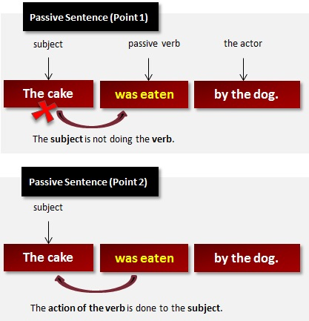

More Examples of Passive Sentences
Here are some more examples of passive sentences:
Anita was driven to the theatre. (In this example, Anita did not perform the action of the verb to drive. The action was done to her. She was the recipient of the action.)
• Nowadays, black kites are protected.(The action is being done to the subject, black kites.)
• The olives are stoned and crushed in this room.(The action is being done to the subject, The olives.)

What Is Active Voice? (with Examples)
A verb is said to be in active voice when the subject performs the verb.
Look at this example of the active voice:
